[WWW.CIOMS.CH](http://WWW.CIOMS.CH/)

December 2020 | **Newsletter # 32**

**International events**

# ECD 2020 conference and DILI webinar

**20 November 2020, Shanghai, China (online conference)**

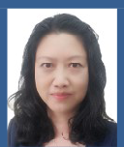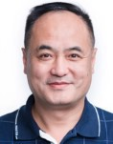

|  |  |  |  |  |
| --- | --- | --- | --- | --- |
| 胡庆澧  Chingli Hu |  |  | 宋海波  Haibo Song | 茅益民  Yimin Mao |
| 张 清  Qing Zhang |
|  |  |  |  | Dominique Sprumont |
| 束芳丽  Fangli Shu | 朱 伟  Wei Zhu | 曹国英 Delia Yi-Dan Guoying Cao Christiani | |
|  |  |  |  |  |
| Panos Tsintis | Lembit Rägo | Arie Robert J  Regev Fontana | |

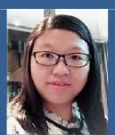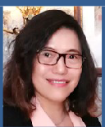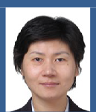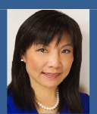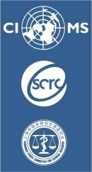



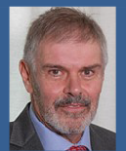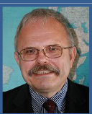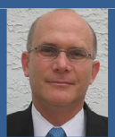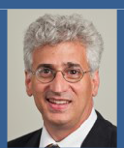

Walter Straus

*The speakers at the ECD 2020 conference.* ***Find the ECD 2020 programme and speakers’ details*** [***here****.*](https://cioms.ch/wp-content/uploads/2020/11/ECD2020_Programme.pdf)

The [International Conference on Pharmaco–](https://mp.weixin.qq.com/s/Ew1LtLD8cSse1GqM7Akf1g) [vigilance and Protection for Research Participants](https://mp.weixin.qq.com/s/Ew1LtLD8cSse1GqM7Akf1g) [(ECD 2020)](https://mp.weixin.qq.com/s/Ew1LtLD8cSse1GqM7Akf1g) was organized by the Shanghai Clinical Research Center (SCRC) / Shanghai Ethics Committee for Clinical Research (SECCR) and CIOMS. The international speakers included CIOMS representatives and experts from the DILI Working Group. Over 2,000 viewers globally from pharmaceutical companies, medical institutions, hospitals, drug administrations and ethics committees joined this online event, which was presented with simultaneous translation in both Mandarin and English.

Part 1 of the conference included presentations by two speakers from CIOMS: Dominique Sprumont described *The Swiss experience of handling ethical review of COVID-19-related applications*, and Panos Tsintis spoke about *Safety monitoring during clinical trials.*

Part 2 was a 90-minute webinar presenting the [CIOMS consensus report on drug-induced liver](https://cioms.ch/publications/product/drug-induced-liver-injury/) [injury (DILI](https://cioms.ch/publications/product/drug-induced-liver-injury/)), which was published earlier this year.

***Videos of the presentations are found** [**here.**](https://mp.weixin.qq.com/s/Ew1LtLD8cSse1GqM7Akf1g)

# DIA-NIFDS Pharmacovigilance Workshop

**18 November 2020, Korea (virtual event)**

This workshop, hosted by the Drug Information Association (DIA) and the National Institute of Food and Drug Safety Evaluation (NIFDS) of the Republic of Korea, provided a platform for regulatory authorities, academia, investigators and industry to share their insights around the theme of [*Diversification in the Practical Application of*](https://www.diaglobal.org/en/conference-listing/meetings/2020/11/dia-nifds-pharmacovigilance-workshop-diversification-in-the-practical-application-of-pharmacovigilance/agenda/effective-presentation-of-safety-data-on-label?ref=Effectivepresentationofsafetydataonlabel)[*Pharmacovigilance*](https://www.diaglobal.org/en/conference-listing/meetings/2020/11/dia-nifds-pharmacovigilance-workshop-diversification-in-the-practical-application-of-pharmacovigilance/agenda/effective-presentation-of-safety-data-on-label?ref=Effectivepresentationofsafetydataonlabel). Held in a virtual format for the first time ever, the event attracted 162 participants on the day, a record number for this workshop.

Present and former CIOMS Working Group members Ilona Große-Michaelis and William Gregory from the CIOMS Working Group on MedDRA Labelling Groupings (MLG) gave a presentation on *Near-Synonymous MedDRA® Terms in Medical Product Labeling*. Issues around safety information updates, practical approaches in active safety surveillance, and safety management of cell and gene therapy products were also discussed at the workshop. Stuart Geary, a long- standing member of several CIOMS Working Groups, spoke about *Evaluation of Safety Information for Labelling*.

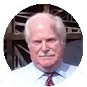 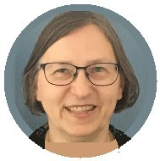 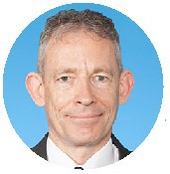

*From left: Former and present CIOMS Working Group members William Gregory, Ilona Große-Michaelis and Stuart Geary.* ***Find more details about the workshop and a list of speakers*** [***here***](https://www.diaglobal.org/conference-listing/meetings/2020/11/dia-nifds-pharmacovigilance-workshop-diversification-in-the-practical-application-of-pharmacovigilance)***.***

# Learn more about the work of CIOMS in pharmacovigilance:

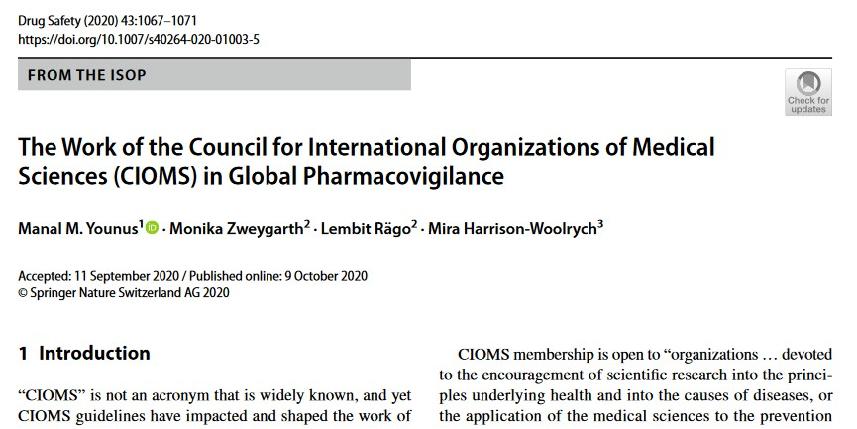

[Drug Saf. 2020 Nov;43(11):1067-1071.](https://link.springer.com/article/10.1007/s40264-020-01003-5)

December 2020 | Newsletter # 32 3